**CN vs MCIc – Z axis (Transverse plane)**



**Approach 1 - 2019_04_23_13_56**

**Network:**

Transfer learning from AlexNet changing last 3 layers.

|  |  |
| --- | --- |
| **Training parameters:**   * folds=3; * miniBatchSize = 30; * learningRate = 1e-4; * maxEpochs=30; * optimizer='sgdm'; * "L2Regularization",1e-04,... * "Momentum",0.889 * ‘Shuffle’,’every-epoch’,… | **Dataset:**   * nPictures=6; * gap=2; * k=1; |

**Results:**

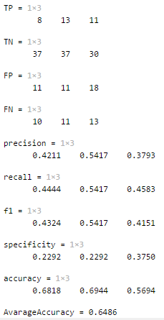

**Approach 2 - 2019_04_23_14_09**

**Network:**

Transfer learning from AlexNet changing last 3 layers.

|  |  |
| --- | --- |
| **Training parameters:**   * folds=3; * miniBatchSize = 24; * learningRate = 1e-4; * maxEpochs=20; * optimizer='sgdm'; * "L2Regularization",1e-04,... * "Momentum",0.889 * ‘Shuffle’,’every-epoch’,… | **Dataset:**   * nPictures=6; * gap=2; * k=1; |

**Results:**

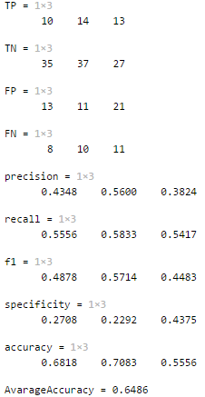

**Approach 3 - 2019_04_23_14_20**

**Network:**

Transfer learning from AlexNet changing last 3 layers.

|  |  |
| --- | --- |
| **Training parameters:**   * folds=3; * miniBatchSize = 24; * learningRate = 1e-4; * maxEpochs=20; * optimizer='sgdm'; * "L2Regularization",1e-04,... * "Momentum",0.889 * ‘Shuffle’,’every-epoch’,… | **Dataset:**   * nPictures=6; * gap=2; * k=1; |

**Results:**

